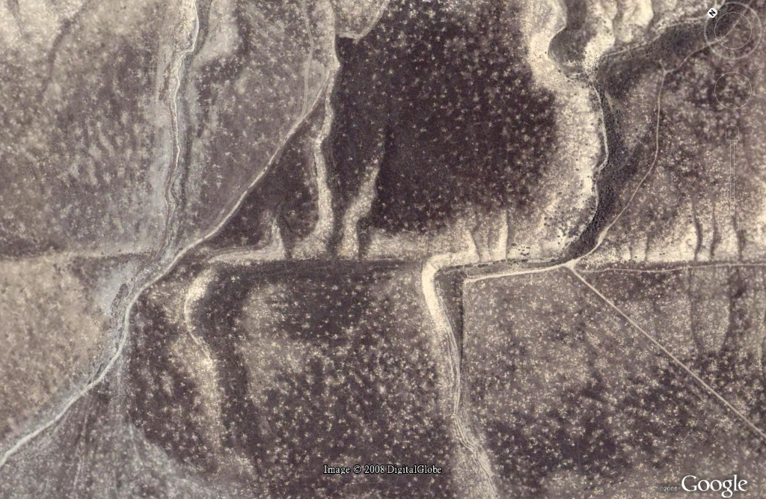
750 feet
Wallace Creek, San Andreas Fault
California

